**Socket programming**

**Client**

// A Java program for a Client

import java.net.*;

import java.io.*;

public class Client

{

// initialize socket and input output streams

private Socket socket = null;

private DataInputStream input = null;

private DataOutputStream out = null;

// constructor to put ip address and port

public Client(String address, int port)

{

// establish a connection

try

{

socket = new Socket(address, port);

System.out.println("Connected");

// takes input from terminal

input = new DataInputStream(System.in);

// sends output to the socket

out = new DataOutputStream(socket.getOutputStream());

}

catch(UnknownHostException u)

{

System.out.println(u);

}

catch(IOException i)

{

System.out.println(i);

}

// string to read message from input

String line = "";

// keep reading until "Over" is input

while (!line.equals("Over"))

{

try

{

line = input.readLine();

out.writeUTF(line);

}

catch(IOException i)

{

System.out.println(i);

}

}

// close the connection

try

{

input.close();

out.close();

socket.close();

}

catch(IOException i)

{

System.out.println(i);

}

}

public static void main(String args[])

{

Client client = new Client("127.0.0.1", 5000);

}

}

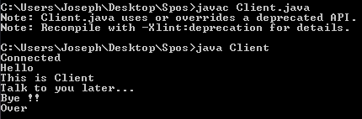

**Server**

import java.net.*;

import java.io.*;

public class Server

{

//initialize socket and input stream

private Socket socket = null;

private ServerSocket server = null;

private DataInputStream in = null;

// constructor with port

public Server(int port)

{

// starts server and waits for a connection

try

{

server = new ServerSocket(port);

System.out.println("Server started");

System.out.println("Waiting for a client ...");

socket = server.accept();

System.out.println("Client accepted");

// takes input from the client socket

in = new DataInputStream(

new BufferedInputStream(socket.getInputStream()));

String line = "";

// reads message from client until "Over" is sent

while (!line.equals("Over"))

{

try

{

line = in.readUTF();

System.out.println(line);

}

catch(IOException i)

{

System.out.println(i);

}

}

System.out.println("Closing connection");

// close connection

socket.close();

in.close();

}

catch(IOException i)

{

System.out.println(i);

}

}

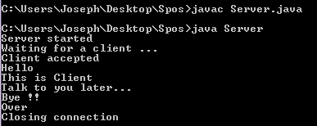

public static void main(String args[])

{

Server server = new Server(5000);

}

}